DBMS ER Diagram Assignment
_____________________________________________
Name- Atulya Mishra
PRN- 202401110051
Topic- Electricity Billing System
Aim
The aim of this system is to manage and automate the lifecycle of electricity distribution and revenue collection. It maintains records for customers, the physical meters installed at their premises, the periodic readings captured from those meters, the bills generated based on consumption, and the subsequent payments made by the consumers.
Description
In this system, customers are registered with personal details and contact information. Each customer can own one or more electricity meters. These meters are of different types and are installed on specific dates to monitor consumption.
Periodically, usage readings are captured. The system distinguishes between two types of readings: Manual Readings, which are recorded by staff members, and Smart Readings, which are automatically synced via a device IP. Once a reading is recorded, the system generates a bill that includes the units consumed, the tax payable, and the total amount due. Customers then settle these bills through various payment methods, either by cash or online transactions.
Table Descriptions
The following tables are defined in the database to store and manage system information:
- CUSTOMER: This table serves as the primary registry for all individuals or entities using the service. It stores personal details like the unique Customer ID (Cid), Name, Email, and Address.
- METER: This table tracks the physical hardware assigned to customers. It records the Meter ID (M_id), the technology type of the meter, and its installation date to manage maintenance and replacement cycles.
- READING: A central table that logs consumption data. It records how many units were consumed, the date of the record, and the specific Reading_ID.
- READING SUBTYPES (Manual & Smart): Depending on the Type attribute in the Reading table, specialized data is stored.
  - Manual_Reading: Stores human-verified data including the ID and name of the staff member who performed the check.
  - Smart_Reading: Logs digital metadata like the Device IP and the last synchronization time from the IoT-enabled meter.
- BILL: This table acts as the financial ledger for usage. It calculates the Total_Amount based on units consumed, adds Tax_payable, and sets strict Due_date and Date_of_issue parameters.
- PAYMENT: This table records all successful financial transactions. It tracks the unique Payment_ID, the exact Amount paid, and the Method used (Cash or Online).

E-R Diagram
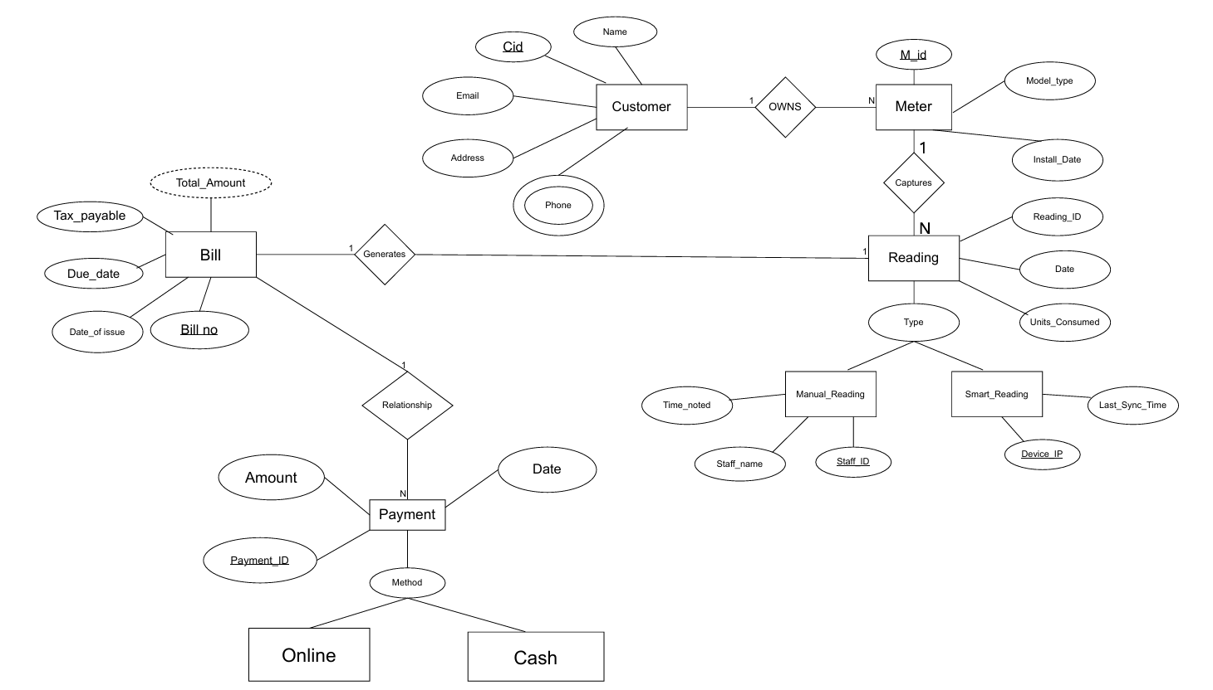
Relational Database Schema for Case Study
The relational schema derived from the ER diagram is as follows:
- CUSTOMER (Cid, Name, Email, Address)
- CUSTOMER_PHONE (Cid, Phone)
- METER (Mid, Model_type, Install_Date, Cid)
- READING (Reading_ID, Date, Units_Consumed, Type, Mid)
- MANUAL_READING (Reading_ID, Time_noted, Staff_name, Staff_ID)
- SMART_READING (Reading_ID, Last_Sync_Time, Device_IP)
- BILL (Bill_no, Date_of_issue, Due_date, Tax_payable, Total_Amount, Reading_ID)
- PAYMENT (Payment_ID, Amount, Date, Method, Bill_no)
Entity and Relationship Logic
The system's integrity is maintained through the following logical associations:
- Customer-Meter (OWNS): This is a 1:N relationship. One customer may have multiple meters (e.g., for different properties), but a single meter is always legally tied to one unique customer ID.
- Meter-Reading (Captures): A 1:N relationship representing the timeline of usage. One physical meter will capture many readings over its lifespan, providing a historical consumption log.
- Reading-Bill (Generates): A 1:1 relationship. Every individual billing cycle is triggered by a specific reading record. One reading results in exactly one generated bill to prevent double-charging.
- Bill-Payment (Relationship): A 1:N relationship. While typically one payment clears one bill, the system allows for multiple payment entries against a single bill number to accommodate partial payments or installments.
Constraints and Referential Integrity
To ensure data quality, the following constraints are applied:
- Primary Keys: Attributes like Cid, M_id, Reading_ID, Bill_no, and Payment_ID must be unique and non-null.
- Foreign Keys:
  - M_id in the Reading table must exist in the Meter table.
  - Cid in the Meter table must exist in the Customer table.
- Specialization: A reading cannot be both "Smart" and "Manual" simultaneously; it must follow the attributes of its specific subtype

